NAME : DEV KUMAR AGE : 16 YRS/ M

Refd. By DR.: K SASIKUMAR DNB ORTHO FIPM

DATE OF REPORT : 09/11/2025

============================================================================== MRI SCREENING SI JOINT

Technique
T1W, STIR
Observations
Evidence of T1 hypo & STIR hyperintensity in the articulation along with mild erosions of the bilateral sacro-iliac joint
Joint space of bilateral sacroiliac joints is normal.
Presacral soft tissue appears normal.
No significant fluid collection is seen.
Sacral wings appear normal.
Sacral foramina appear normal.
Impression
Evidence of T1 hypo & STIR hyperintensity in the articulation along with mild erosions of the bilateral sacro-iliac joint
F/S/O Possibility of Sacroilitis.
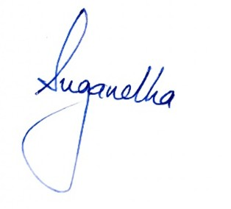
Suggested : Detailed CE MRI SI Joint

